

Year Five

Parents’ Leaflet

How to support your child

with Maths at home

**By the end of Year 5 your child should;**

* Read and write numbers to 1,000,000.
* Count forwards and backwards in steps of 100, 1,000, 10,000 from any given number to 1,000,000.
* Round numbers to the nearest 10, 100, 1,000, 10,000 and 100,000 with numbers up to 1,000,000.
* Add and subtract numbers with up to 5 digits.
* Know by heart all prime numbers to 19.
* Multiply numbers up to 4-digits by a 1 or 2-digit number using formal methods.
* Divide numbers up to 4-digits by a 1-digit number and 10 (with remainders).
* Quickly multiply and divide numbers by 10, 100 and 1000.
* Compare and order fractions with different denominations.
* Recognise and use square numbers and square roots and symbols (²) and (√)
* Estimate answers to additions, subtractions, multiplications and divisions.
* Read Roman numerals to 1,000 (M)
* Use vocabulary: prime numbers; prime factors and composite (non-prime) numbers.
* Recognise mixed numbers and improper fractions and convert one form to the other.

**Ideas for games you can play around the house**

**Decimal number plates**

♦ Each choose a car number plate with three digits

|  |
| --- |
| **P645 CJM** |

♦ Choose two of the digits, e.g. 4 and 6. Make the smallest and largest numbers you can, each with 1 decimal places, e.g. 4.6 and 6.4

♦ Now find the difference between the two decimal numbers, e.g. 6.4 – 4.6 = 1.8

♦ Whoever makes the biggest difference scores 10 points

♦ The person with the most points wins

Play the game again, but this time score 10 points for the smallest difference, or 10 points for the biggest total.

**Finding areas and perimeters**

*Perimeter = distance around the edge of a shape*

*Area of a rectangle = length x breadth (width)*

♦ Collect 5 or 6 used envelopes of different sizes.

♦ Ask your child to estimate the perimeter of each one to the nearest centimetre. Write the estimate on the back.

♦ Now measure. Write the estimate next to the measurement.

♦ How close did your child get?

♦ Now estimate then work out the area of each envelope.

♦ Were perimeters or areas easier to estimate? Why? You could do something similar using an old newspaper, e.g.

♦ Work out which page has the biggest area used for photographs.

♦ Choose a page and work out the total area of news stories or adverts on that page.

**C:\Users\i.cork\AppData\Local\Microsoft\Windows\Temporary Internet Files\Content.IE5\0X2F6Y4O\MC900384026[1].wmfC:\Users\i.cork\AppData\Local\Microsoft\Windows\Temporary Internet Files\Content.IE5\0SAMUKE9\MC900389514[1].wmfC:\Users\i.cork\AppData\Local\Microsoft\Windows\Temporary Internet Files\Content.IE5\Q8V7GKM0\MC900326274[1].wmfC:\Users\i.cork\AppData\Local\Microsoft\Windows\Temporary Internet Files\Content.IE5\A070IYVQ\MC900233523[1].wmfC:\Users\i.cork\AppData\Local\Microsoft\Windows\Temporary Internet Files\Content.IE5\AGC7S55U\MC900030285[1].wmf**

**Tables**

Practise all the 12x tables. Say them forwards and backwards.

Ask your child questions like:

What are five threes?

What is 36 divided by 6?

Seven times nine?

How many eights in 48?

Make a times-table grid like this.

♦ Shade in all the tables facts that your child knows, probably the 1s,

2s, 3s, 4s, 5s and 10s

♦ Some facts appear twice, e.g. 7 x 3 and 3 x 7, so cross out one of each

♦ Are you surprised how few facts are left?

♦ There might only be 10 facts to learn. So take one fact a day and

make up a silly rhyme together to help your child to learn it,

e.g. *nine sevens are sixty-three, let's have lots of chips for tea!*

[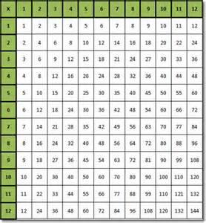](http://images.search.yahoo.com/images/view;_ylt=A2KJkP05sU1SOToAFX2JzbkF;_ylu=X3oDMTFxdm5vMjlvBHNlYwNzcgRzbGsDaW1nBG9pZAMwZWI4OTJhZGNhNDk2NDAxOTA4ZGMyZGIzNGEwMmQ0ZgRncG9zAzQ-?back=http://images.search.yahoo.com/yhs/search?p%3Dtimes%2Btables%26hsimp%3Dyhs-yhsifmclone1%26hspart%3DBabylon%26tab%3Dorganic%26ri%3D4&w=502&h=541&imgurl=www.word-2010.com/wp-content/uploads/2010/06/type-in-times-table.gif&rurl=http://www.word-2010.com/multiplication-table-template/&size=19KB&name=Type+In+%3cb%3eTimes+%3c/b%3eTable+Template&p=times+tables&oid=0eb892adca496401908dc2db34a02d4f&fr2=&fr=&tt=Type+In+%3cb%3eTimes+%3c/b%3eTable+Template&b=0&ni=160&no=4&ts=&tab=organic&sigr=11npgc8gj&sigb=13ff5ei6u&sigi=124ur5dhn&.crumb=xmYZPvxvIA6&hsimp=yhs-yhsifmclone1&hspart=Babylon)

**How much?**

♦ While shopping, point out an item costing less than £1.

♦ Ask your child to work out in their head the cost of 3 items.

♦ Ask them to guess first. See how close they come.

♦ If you see any items labelled, for example, ‘2 for £3.50’, ask them to work out the cost of 1 item for you, and to explain how they got the answer.



**Telephone challenges**

♦ Challenge your child to find numbers in the telephone directory where the digits add up to 42

♦ Find as many as possible in 10 minutes

♦ On another day, see if they can beat their previous total

Telephone: 01264 738 281 

**Target 1000** C:\Users\i.cork\AppData\Local\Microsoft\Windows\Temporary Internet Files\Content.IE5\CKJSX2CR\MC900326186[1].wmf

♦ Roll a dice 6 times

♦ Use the six digits to make two three-digit numbers

♦ Add the two numbers together

♦ How close to 1000 can you get?

**Car numbers**



|  |
| --- |
| **P456 CTO** |

♦ Try reading a car number as a measurement in centimetres, then converting it to metres, e.g. 456cm, which is 4.56m, or 4m and 56cm.

♦ Try this with car numbers that have zeros in them, e.g. 307cm, which is 3.07m or 3m and 7cm; 370cm, which is 3.7m, or 3m and 70cm. These are harder!

### Dicey subtractions C:\Users\i.cork\AppData\Local\Microsoft\Windows\Temporary Internet Files\Content.IE5\Q8V7GKM0\MC900389040[1].wmf

♦ Take turns to roll a dice twice

♦ Fill in the missing boxes. 400􀂆 - 399􀂆 e.g. 4002 – 3994

♦ Count on from the smaller to the larger number, e.g *3995, 3996, 3997, 3998, 3999, 4000, 4001, 4002*

♦ You counted on 8, so you score 8 points

♦ Keep a running total of your score

♦ The first to get 50 or more points wins

**Line it up**

You need a ruler marked in centimetres and millimetres.

♦ Use the ruler to draw 10 different straight lines on a piece of paper.

♦ Ask your child to estimate the length of each line and write the estimate on the line.

♦ Now give them the ruler and ask them to measure each line to the nearest millimetre.

♦ Ask them to write the measurement next to the estimate, and work out the difference.

♦ A difference of 5 millimetres or less scores 10 points. A difference of 1 centimetre or less scores 5 points.

♦ How close to 100 points can she get?

C:\Users\i.cork\AppData\Local\Microsoft\Windows\Temporary Internet Files\Content.IE5\SO8UBMVP\MC900232723[1].wmf

## Guess my number

## ???????????????

♦ Choose a number between 0 and 1 with one decimal place, e.g. 0.6

♦ Challenge your child to ask you questions to guess your number. You may only answer ‘Yes’ or ‘No’. For example, he could ask questions like ‘Is it less than a half?’

♦ See if he can guess your number in fewer than 5 questions

♦ Now let your child choose a mystery number for you to guess

Extend the game by choosing a number with one decimal place between 1 and 10, e.g. 3.6. You may need more questions!

**Car numbers**

♦ Choose a car number.

♦ You may add or subtract 10, 20, 30, 40, 50, 60, 70, 80 or 90.

♦ Try to get as close as possible to 555.

♦ Who can get closest during a week?

**Dicey division C:\Users\i.cork\AppData\Local\Microsoft\Windows\Temporary Internet Files\Content.IE5\CKJSX2CR\MC900232251[1].wmf**

For this game you need a 1–100 board (a snakes and ladders board will do), a dice and 20 coins or counters.

♦ Take turns

♦ Choose a two-digit number. Roll a dice. If you roll 1, roll again

♦ If your two-digit number divides exactly by the dice number, put a coin on your chosen two-digit number. Otherwise, miss that turn

♦ The first to get 10 counters on the board wins

[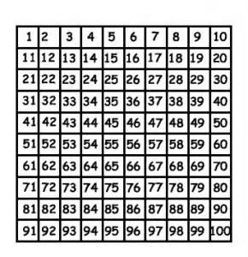](http://images.search.yahoo.com/images/view;_ylt=A2KJkK7btU1SiUsAkySJzbkF;_ylu=X3oDMTFyaXRvZXZuBHNlYwNzcgRzbGsDaW1nBG9pZAMxNmI1Y2UyN2FmNDI4ZDIxYTkyZDg5NGVmMzNlZGZiMgRncG9zAzE5?back=http://images.search.yahoo.com/yhs/search?p%3D100%2Bsquare%26hsimp%3Dyhs-yhsifmclone1%26hspart%3DBabylon%26tab%3Dorganic%26ri%3D19&w=290&h=300&imgurl=year52012.worsbroughcblogs.net/files/2013/05/100square-290x300.jpg&rurl=http://year52012.worsbroughcblogs.net/2013/05/02/100-square-challenge-by-harvey-ct/&size=39KB&name=%3cb%3e100+square+%3c/b%3echallenge+by+Harvey+CT&p=100+square&oid=16b5ce27af428d21a92d894ef33edfb2&fr2=&fr=&tt=%3cb%3e100+square+%3c/b%3echallenge+by+Harvey+CT&b=0&ni=160&no=19&ts=&tab=organic&sigr=12jdlo3mv&sigb=13e74j4ec&sigi=122hrsfg8&.crumb=xmYZPvxvIA6&hsimp=yhs-yhsifmclone1&hspart=Babylon)

[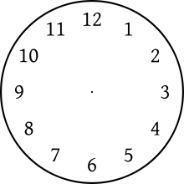](http://www.google.co.uk/url?sa=i&source=images&cd=&cad=rja&docid=EuPI-ildoRxTWM&tbnid=gnl_kpriSAkuAM:&ved=0CAgQjRwwAA&url=http://en.wikipedia.org/wiki/Clock_position&ei=NopMUrO5N-eG0AWK4IDQDQ&psig=AFQjCNEgKmKBES0-9t3R2iOoywCjOS2Y7Q&ust=1380834231035619)

**What time is it please?**

**Can you tell the time?**

Whenever possible, ask your child to tell you the time to the nearest 5 minutes. Use a clock with hands as well as a digital watch or clock.

Also ask:

♦ What time will it be one hour from now?

♦ What time was it one hour ago?

Time your child doing various tasks, e.g.

♦ getting ready for school;

♦ tidying a bedroom;

♦ saying the 5 times, 10 times or 2 times table…

Ask your child to guess in advance how long they think an activity will take. Can they beat their time when they repeat it?



Internet resources

Hit the Button

www.woodlands-junior.kent.sch.uk/maths

mathschamps.co.uk (Brick blaster)

www.topmarks.co.uk

www.mathszone.co.uk

www.bbc.co.uk/bitesize/ks2/maths

www.primaryinteractive.co.uk

Maths Magician (coolsciencelab.com/math_magician)

MyMiniMaths – This is a fantastic resource which gives children the opportunity to practise all aspects of the curriculum for their year group. Every day 8 questions are given and the answers are available.

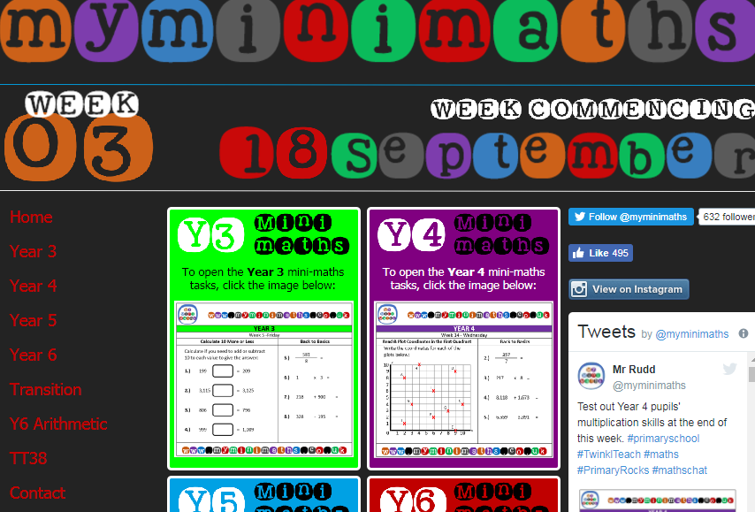

The Government has introduced a new National Curriculum for Maths in September 2014. Enclosed is the programme of study for this year group which states what children should be taught and know by the end of the year.

**Year 5 programme of study**

**By the end of the year children should be able to:**

**Number - number and place value**

* read, write, order and compare numbers to at least 1,000,000 and determine the value of each digit
* count forwards or backwards in steps of powers of 10 for any given number up to 1,000,000
* interpret negative numbers in context, count forwards and backwards with positive and negative whole numbers, including through 0
* round any number up to 1,000,000 to the nearest 10, 100, 1,000, 10,000 and 100,000
* solve number problems and practical problems that involve all of the above
* read Roman numerals to 1,000 (M) and recognise years written in Roman numerals

**Number - calculations**

* add and subtract whole numbers with more than 4 digits, including using formal written methods (columnar addition and subtraction)
* add and subtract numbers mentally with increasingly large numbers
* use rounding to check answers to calculations and determine, in the context of a problem, levels of accuracy
* solve addition and subtraction multi-step problems in contexts, deciding which operations and methods to use and why
* identify multiples and factors, including finding all factor pairs of a number, and common factors of 2 numbers
* know and use the vocabulary of prime numbers, prime factors and composite (non-prime) numbers
* establish whether a number up to 100 is prime and recall prime numbers up to 19
* multiply numbers up to 4 digits by a one- or two-digit number using a formal written method, including long multiplication for two-digit numbers
* multiply and divide numbers mentally, drawing upon known facts
* divide numbers up to 4 digits by a one-digit number using the formal written method of short division and interpret remainders appropriately for the context
* multiply and divide whole numbers and those involving decimals by 10, 100 and 1,000
* recognise and use square numbers and cube numbers, and the notation for squared (²) and cubed (³)
* solve problems involving multiplication and division, including using their knowledge of factors and multiples, squares and cubes
* solve problems involving addition, subtraction, multiplication and division and a combination of these, including understanding the meaning of the equals sign
* solve problems involving multiplication and division, including scaling by simple fractions and problems involving simple rates

**Number - fractions (including decimals and percentages)**

* compare and order fractions whose denominators are all multiples of the same number
* identify, name and write equivalent fractions of a given fraction, represented visually, including tenths and hundredths
* recognise mixed numbers and improper fractions and convert from one form to the other and write mathematical statements > 1 as a mixed number [for example, 2/5+ 4/5= 6/5= 1 1/5]
* add and subtract fractions with the same denominator, and denominators that are multiples of the same number
* multiply proper fractions and mixed numbers by whole numbers, supported by materials and diagrams
* read and write decimal numbers as fractions [for example, 0.71 = 71/100]
* recognise and use thousandths and relate them to tenths, hundredths and decimal equivalents
* round decimals with 2 decimal places to the nearest whole number and to 1 decimal place
* read, write, order and compare numbers with up to 3 decimal places
* solve problems involving number up to 3 decimal places
* recognise the per cent symbol (%) and understand that per cent relates to ‘number of parts per 100’, and write percentages as a fraction with denominator 100, and as a decimal fraction
* solve problems which require knowing percentage and decimal equivalents of 1/2, 1/4, 1/5, 2/5, 4/5and those fractions with a denominator of a multiple of 10 or 25

**Measurement**

* convert between different units of metric measure [for example, kilometre and metre; centimetre and metre; centimetre and millimetre; gram and kilogram; litre and millilitre]
* understand and use approximate equivalences between metric units and common imperial units such as inches, pounds and pints
* measure and calculate the perimeter of composite rectilinear shapes in centimetres and metres
* calculate and compare the area of rectangles (including squares), including using standard units, square centimetres (cm²) and square metres (m²), and estimate the area of irregular shapes
* estimate volume [for example, using 1 cm³ blocks to build cuboids (including cubes)] and capacity [for example, using water]
* solve problems involving converting between units of time
* use all four operations to solve problems involving measure [for example, length, mass, volume, money] using decimal notation, including scaling

**Geometry - properties of shapes**

* identify 3-D shapes, including cubes and other cuboids, from 2-D representations
* know angles are measured in degrees: estimate and compare acute, obtuse and reflex angles
* draw given angles, and measure them in degrees (°)
* identify:
  + angles at a point and 1 whole turn (total 360°)
  + angles at a point on a straight line and half a turn (total 180°)
  + other multiples of 90°
  + use the properties of rectangles to deduce related facts and find missing lengths and angles
  + distinguish between regular and irregular polygons based on reasoning about equal sides and angles

**Geometry - position and direction**

* identify, describe and represent the position of a shape following a reflection or translation, using the appropriate language, and know that the shape has not changed

**Statistics**

* solve comparison, sum and difference problems using information presented in a line graph
* complete, read and interpret information in tables, including timetables