National Curriculum 2014 Planning Document
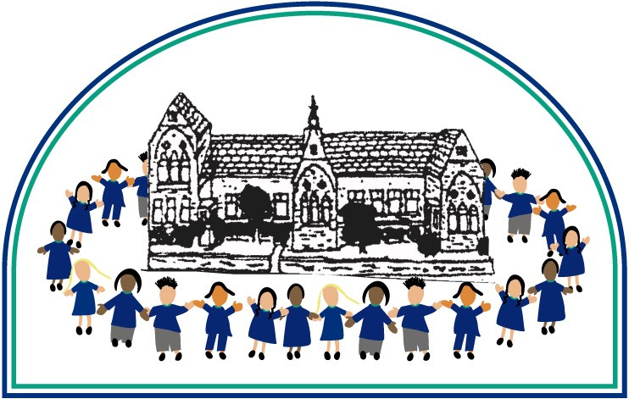
Y1
Spelling Appendix
This document contains the Y1 Spelling appendix and should be used to support the planning, teaching and learning of Spelling in Year 1.

Spelling – work for year 1

Revision of reception work

Statutory requirements
The boundary between revision of work covered in Reception and the introduction of new work may vary according to the programme used, but basic revision should include:
- all letters of the alphabet and the sounds which they most commonly represent
- consonant digraphs which have been taught and the sounds which they represent
- vowel digraphs which have been taught and the sounds which they represent
- the process of segmenting spoken words into sounds before choosing graphemes to represent the sounds
- words with adjacent consonants
- guidance and rules which have been taught

Statutory requirements |  | Rules and guidance (non-statutory) | Example words (non-statutory)
The sounds /f/, /l/, /s/, /z/ and /k/ spelt ff, ll, ss, zz and ck |  | The /f/, /l/, /s/, /z/ and /k/ sounds are usually spelt as ff, ll, ss, zz and ck if they come straight after a single vowel letter in short words. Exceptions: if, pal, us, bus, yes. | off, well, miss, buzz, back
The /ŋ/ sound spelt n before k |  |  | bank, think, honk, sunk
Division of words into syllables |  | Each syllable is like a ‘beat’ in the spoken word. Words of more than one syllable often have an unstressed syllable in which the vowel sound is unclear. | pocket, rabbit, carrot, thunder, sunset

Statutory requirements |  | Rules and guidance (non-statutory) | Example words (non-statutory)
-tch |  | The /tʃ/ sound is usually spelt as tch if it comes straight after a single vowel letter. Exceptions: rich, which, much, such. | catch, fetch, kitchen, notch, hutch
The /v/ sound at the end of words |  | English words hardly ever end with the letter v, so if a word ends with a /v/ sound, the letter e usually needs to be added after the ‘v’. | have, live, give
Adding s and es to words (plural of nouns and the third person singular of verbs) |  | If the ending sounds like /s/ or /z/, it is spelt as –s. If the ending sounds like /ɪz/ and forms an extra syllable or ‘beat’ in the word, it is spelt as –es. | cats, dogs, spends, rocks, thanks, catches
Adding the endings –ing, –ed and –er to verbs where no change is needed to the root word |  | –ing and –er always add an extra syllable to the word and –ed sometimes does.  The past tense of some verbs may sound as if it ends in /ɪd/ (extra syllable), /d/ or /t/ (no extra syllable), but all these endings are spelt –ed.  If the verb ends in two consonant letters (the same or different), the ending is simply added on. | hunting, hunted, hunter, buzzing, buzzed, buzzer, jumping, jumped, jumper
Adding –er and –est to adjectives where no change is needed to the root word |  | As with verbs (see above), if the adjective ends in two consonant letters (the same or different), the ending is simply added on. | grander, grandest, fresher, freshest, quicker, quickest

Vowel digraphs and trigraphs
Some may already be known, depending on the programmes used in Reception, but some will be new.
Vowel digraphs and trigraphs |  | Rules and guidance (non-statutory) | Example words (non-statutory)
ai, oi |  | The digraphs ai and oi are virtually never used at the end of English words. | rain, wait, train, paid, afraid  oil, join, coin, point, soil
ay, oy |  | ay and oy are used for those sounds at the end of words and at the end of syllables. | day, play, say, way, stay  boy, toy, enjoy, annoy
a–e |  |  | made, came, same, take, safe
e–e |  |  | these, theme, complete
i–e |  |  | five, ride, like, time, side
o–e |  |  | home, those, woke, hope, hole
u–e |  | Both the /u:/ and /ju:/ (‘oo’ and ‘yoo’) sounds can be spelt as u–e. | June, rule, rude, use, tube, tune
ar |  |  | car, start, park, arm, garden
ee |  |  | see, tree, green, meet, week
ea (/i:/) |  |  | sea, dream, meat, each, read (present tense)
ea (/ɛ/) |  |  | head, bread, meant, instead, read (past tense)
er (/ɜ:/) |  |  | (stressed sound): her, term, verb, person
er (/ə/) |  |  | (unstressed schwa sound): better, under, summer, winter, sister
ir |  |  | girl, bird, shirt, first, third
ur |  |  | turn, hurt, church, burst, Thursday

Vowel digraphs and trigraphs |  | Rules and guidance (non-statutory) | Example words (non-statutory)
oo (/u:/) |  | Very few words end with the letters oo, although the few that do are often words that primary children in year 1 will encounter, for example, zoo | food, pool, moon, zoo, soon
oo (/ʊ/) |  |  | book, took, foot, wood, good
oa |  | The digraph oa is very rare at the end of an English word. | boat, coat, road, coach, goal
oe |  |  | toe, goes
ou |  | The only common English word ending in ou is you. | out, about, mouth, around, sound
ow (/aʊ/)  ow (/əʊ/)  ue  ew |  | Both the /u:/ and /ju:/ (‘oo’ and ‘yoo’) sounds can be spelt as u–e, ue and ew. If words end in the /oo/ sound, ue and ew are more common spellings than oo. | now, how, brown, down, town  own, blow, snow, grow, show  blue, clue, true, rescue, Tuesday  new, few, grew, flew, drew, threw
ie (/aɪ/) |  |  | lie, tie, pie, cried, tried, dried
ie (/i:/) |  |  | chief, field, thief
igh |  |  | high, night, light, bright, right
or |  |  | for, short, born, horse, morning
ore |  |  | more, score, before, wore, shore
aw |  |  | saw, draw, yawn, crawl
au |  |  | author, August, dinosaur, astronaut
air |  |  | air, fair, pair, hair, chair
ear |  |  | dear, hear, beard, near, year
ear (/ɛə/) |  |  | bear, pear, wear
are (/ɛə/) |  |  | bare, dare, care, share, scared

Statutory requirements |  | Rules and guidance (non-statutory) | Example words (non-statutory)
Words ending –y (/i:/ or /ɪ/) |  |  | very, happy, funny, party, family
New consonant spellings ph and wh |  | The /f/ sound is not usually spelt as ph in short everyday words (e.g. fat, fill, fun). | dolphin, alphabet, phonics, elephant  when, where, which, wheel, while
Using k for the /k/ sound |  | The /k/ sound is spelt as k rather than as c before e, i and y. | Kent, sketch, kit, skin, frisky
Adding the prefix –un |  | The prefix un– is added to the beginning of a word without any change to the spelling of the root word. | unhappy, undo, unload, unfair, unlock
Compound words |  | Compound words are two words joined together. Each part of the longer word is spelt as it would be if it were on its own. | football, playground, farmyard, bedroom, blackberry
Common exception words |  | Pupils’ attention should be drawn to the grapheme-phoneme correspondences that do and do not fit in with what has been taught so far. | the, a, do, to, today, of, said, says, are, were, was, is, his, has, I, you, your, they, be, he, me, she, we, no, go, so, by, my, here, there, where, love, come, some, one, once, ask, friend, school, put, push, pull, full, house, our – and/or others, according to the programme used

