

Year Six

Parents’ Leaflet

How to support your child

with Maths at home

**By the end of Year 6 your child should;**

* Read and write numbers to 10,000,000
* Round any number to any degree of accuracy
* Add and subtract negative integers
* Use tables to work with decimals (to 1dp)
* Multiply 4-digit whole numbers by 2-digit whole numbers
* Divide numbers up to 4-digits by a 2-digit whole numbers and recognise remainders
* Multiply and divide decimals by 10, 100 or 1000 in the head
* Multiply and divide a number with up to two decimal places by 1-digit and 2-digit whole numbers
* Work out simple % of whole numbers
* Use ratio to show the relative sizes of two quantities
* Add and subtract mixed numbers and fractions with different denominations
* Recall and use equivalences between fractions, decimals and percentages
* Solve linear missing number problems, including those involving decimals and fractions

**Ideas for games you can play around the house**

**TV addicts**

Ask your child to keep a record of how long he / she watches TV

each day for a week. Then ask him / her to do this

♦ Work out the total watching time for the week

♦ Work out the average watching time for a day (that is, the total time divided by 7). Instead of watching TV, you could ask them to keep a record of time spent eating meals, or playing outdoors, or anything else they do each day. Then work out the daily average

C:\Users\i.cork\AppData\Local\Microsoft\Windows\Temporary Internet Files\Content.IE5\7AV3PNDK\MC900432517[1].wmf

**Four in a line**

Draw a 6 x 7 grid.

Fill it with numbers under 100.

|  |  |  |  |  |  |  |
| --- | --- | --- | --- | --- | --- | --- |
| **54** | **47** | **21** | **19** | **5** | **38** | **58** |
| **9** | **25** | **67** | **56** | **49** | **13** | **17** |
| **39** | **41** | **6** | **1** | **75** | **28** | **36** |
| **90** | **14** | **50** | **81** | **23** | **43** | **2** |
| **14** | **50** | **81** | **23** | **43** | **4** | **55** |
| **37** | **45** | **29** | **72** | **34** | **7** | **11** |

♦ Take turns

♦ Roll three dice, or roll one dice three times

♦ Use all three numbers to make a number on the grid

♦ You can add, subtract, multiply or divide the numbers, e.g. if you roll 3, 4 and 5, you could make 3 x 4 – 5 = 7, 54 ÷ 3 = 18, (4 + 5) x 3 = 27, and so on

♦ Cover the number you make with a coin or counter

♦ The first to get four of their counters in a straight line wins

**Tables**

Practise all the 12x tables. Say them forwards and backwards.

Ask your child questions like:

What are five threes?

What is 36 divided by 6?

Seven times nine?

How many eights in 48?

Make a times-table grid like this.

♦ Shade in all the tables facts that your child knows, probably the 1s,

2s, 3s, 4s, 5s and 10s

♦ Some facts appear twice, e.g. 7 x 3 and 3 x 7, so cross out one of each

♦ Are you surprised how few facts are left?

♦ There might only be 10 facts to learn. So take one fact a day and

make up a silly rhyme together to help your child to learn it,

e.g. *nine sevens are sixty-three, let's have lots of chips for tea!*

[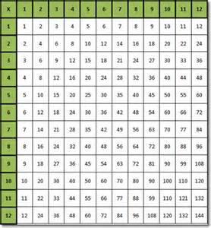](http://images.search.yahoo.com/images/view;_ylt=A2KJkP05sU1SOToAFX2JzbkF;_ylu=X3oDMTFxdm5vMjlvBHNlYwNzcgRzbGsDaW1nBG9pZAMwZWI4OTJhZGNhNDk2NDAxOTA4ZGMyZGIzNGEwMmQ0ZgRncG9zAzQ-?back=http://images.search.yahoo.com/yhs/search?p%3Dtimes%2Btables%26hsimp%3Dyhs-yhsifmclone1%26hspart%3DBabylon%26tab%3Dorganic%26ri%3D4&w=502&h=541&imgurl=www.word-2010.com/wp-content/uploads/2010/06/type-in-times-table.gif&rurl=http://www.word-2010.com/multiplication-table-template/&size=19KB&name=Type+In+%3cb%3eTimes+%3c/b%3eTable+Template&p=times+tables&oid=0eb892adca496401908dc2db34a02d4f&fr2=&fr=&tt=Type+In+%3cb%3eTimes+%3c/b%3eTable+Template&b=0&ni=160&no=4&ts=&tab=organic&sigr=11npgc8gj&sigb=13ff5ei6u&sigi=124ur5dhn&.crumb=xmYZPvxvIA6&hsimp=yhs-yhsifmclone1&hspart=Babylon)

**Rhymes**

Make up rhymes together to help your child to remember the

harder times-tables facts, e.g.

6 x 7 = 42 phew! 7 x 7 = 49 fine! 6 x 8 = 48 great!

**Favourite food** 

♦ Ask your child the cost of a favourite item of food. Ask them to work out what 7 of them would cost, or 8, or 9. How much change would there be from £50?

♦ Repeat with his / her least favourite food. What is the difference in cost between the two?

**Sale of the century**

♦ When you go shopping, or see a shop with a sale on, ask your child to work out what some items would cost with:

50% off

25% off

10% off

5% off

♦ Ask your child to explain how she worked it out

**Three in a row**

For this game you need a calculator.

Draw a line like this:

PK

[http://ts1.mm.bing.net/th?id=H.4653336261427792&pid=15.1](http://images.search.yahoo.com/images/view;_ylt=A2KJkPyyu01S.ywA4nGJzbkF;_ylu=X3oDMTFxYmh2cHJ0BHNlYwNzcgRzbGsDaW1nBG9pZAMzNzJhMDBlOGNkYjMwZjc1MDNiNzg3NDgxMmJlMGFjYgRncG9zAzQ-?back=http://images.search.yahoo.com/yhs/search?p%3D0.1%2Bnumber%2Bline%26hsimp%3Dyhs-yhsifmclone1%26hspart%3DBabylon%26tab%3Dorganic%26ri%3D4&w=1024&h=87&imgurl=etc.usf.edu/clipart/41600/41653/0-1xtenth_41653_lg.gif&rurl=http://etc.usf.edu/clipart/41600/41653/0-1xtenth_41653.htm&size=8.1KB&name=%3cb%3eNumber+Line%3c/b%3e,+%3cb%3e0+%3c/b%3eto+%3cb%3e1+%3c/b%3eby+Tenths+|+ClipArt+ETC&p=0.1+number+line&oid=372a00e8cdb30f7503b7874812be0acb&fr2=&fr=&tt=%3cb%3eNumber+Line%3c/b%3e,+%3cb%3e0+%3c/b%3eto+%3cb%3e1+%3c/b%3eby+Tenths+|+ClipArt+ETC&b=0&ni=160&no=4&ts=&tab=organic&sigr=11qjie8fo&sigb=13i98nd47&sigi=11mg1aavo&.crumb=xmYZPvxvIA6&hsimp=yhs-yhsifmclone1&hspart=Babylon)

♦ Take it in turns to choose a fraction, say 2/5. Use the calculator to convert it to a decimal (i.e. 2 ÷ 5 = 0.4) and mark your initials at this point on the line

♦ The aim of the game is to get 3 crosses in a row without any

of the other player’s marks in between

♦ Some fractions are harder to place than others, e.g. ninths

**Flowers** 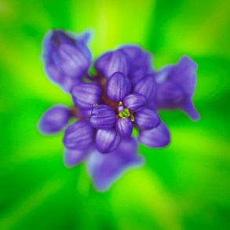

**♦ Take turns to think of a flower**

**♦ Use an alphabet code, A = 1, B = 2, C = 3... up to Z = 26**

**♦ Find the numbers for the first and last letters of your flower, e.g. for a ROSE, R = 18, and E = 5**

**♦ Multiply the two numbers together, e.g. 18 x 5 = 90**

**♦ The person with the biggest answer scores a point**

**♦ The winner is the first to get 5 points**

**When you play again you could think of animals, or countries.**

**Recipes**

Find a recipe for 4 people and rewrite it for 8 people, e.g.

4 people 8 people

125g flour 250g flour

50g butter 100g butter

75g sugar 150g sugar

30ml treacle 60ml treacle

1 teaspoon ginger 2 teaspoons ginger

Can you rewrite it for 3 people? Or 5 people?

**Fours**

♦ Use exactly four 4s each time.

♦ You can add, subtract, multiply or divide them.

♦ Can you make each number from 1 to 100?

♦ Here are some ways of making the first two numbers.

1 = (4 + 4)/(4 + 4)

2 = 4/4 + 4/4

**Card game** 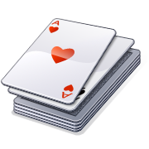

Use a pack of playing cards.

Take out the jacks, queens and kings.

♦ Take turns

♦ Take a card and roll a dice

♦ Multiply the two numbers

♦ Write down the answer. Keep a running total

♦ The first to go over 301 wins!

**Remainders**

Draw a 6 x 6 grid like this.

♦ Choose the 7, 8 or 9 times table

♦ Take turns

♦ Roll a dice

♦ Choose a number on the board, e.g. 59. Divide it by the tables number, e.g. 7. If the remainder for 59 ÷ 7 is the same as the dice number, you can cover the board number with a counter or coin

♦ The first to get four of their counters in a straight line wins!

|  |  |  |  |  |  |
| --- | --- | --- | --- | --- | --- |
| **54** | **47** | **21** | **19** | **5** | **38** |
| **9** | **25** | **67** | **56** | **49** | **13** |
| **39** | **41** | **6** | **1** | **75** | **28** |
| **90** | **14** | **50** | **81** | **23** | **43** |
| **14** | **50** | **81** | **23** | **43** | **4** |
| **37** | **45** | **29** | **72** | **34** | **7** |

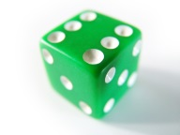**Doubles and trebles**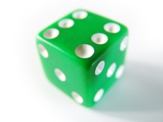

♦ Roll two dice

♦ Multiply the two numbers to get your score

♦ Roll one of the dice again. If it is an even number, double your score. If it is an odd number, treble your score

♦ Keep a running total of your score

♦ The first to get over 301 wins

***Journeys* 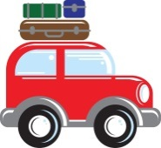**

Use the chart in the front of a road atlas that tells you the distance between places.

♦ Find the nearest place to you

♦ Ask your child to work out how long it would take to travel to some places in England if you travelled at an average of 60 miles per hour, i.e. 1 mile per minute, e.g.

York to Preston: 90 miles 1 hour 30 minutes

York to Dover: 280 miles 4 hours 40 minutes

Encourage your child to count in 60s to work out the answers.

**One million pounds**

Assume you have £1 000 000 to spend or give away.

Plan with your child what to do with it, down to the last penny.

[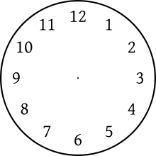](http://www.google.co.uk/url?sa=i&source=images&cd=&cad=rja&docid=EuPI-ildoRxTWM&tbnid=gnl_kpriSAkuAM:&ved=0CAgQjRwwAA&url=http://en.wikipedia.org/wiki/Clock_position&ei=NopMUrO5N-eG0AWK4IDQDQ&psig=AFQjCNEgKmKBES0-9t3R2iOoywCjOS2Y7Q&ust=1380834231035619)

**What time is it please?**

**Can you tell the time?**

Whenever possible, ask your child to tell you the time to the nearest 5 minutes. Use a clock with hands as well as a digital watch or clock.

Also ask:

♦ What time will it be one hour from now?

♦ What time was it one hour ago?

Time your child doing various tasks, e.g.

♦ getting ready for school;

♦ tidying a bedroom;

♦ saying the 5 times, 10 times or 2 times table…

Ask your child to guess in advance how long they think an activity will take. Can they beat their time when they repeat it?



Internet resources

Hit the Button

www.woodlands-junior.kent.sch.uk/maths

mathschamps.co.uk (Brick blaster)

www.topmarks.co.uk

www.mathszone.co.uk

www.bbc.co.uk/bitesize/ks2/maths

www.primaryinteractive.co.uk

Maths Magician (coolsciencelab.com/math_magician)

MyMiniMaths – This is a fantastic resource which gives children the opportunity to practise all aspects of the curriculum for their year group. Every day 8 questions are given and the answers are available.

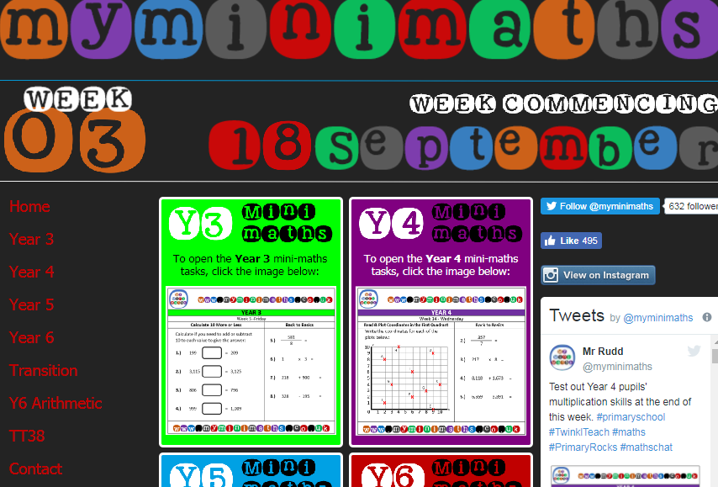

**Year 6 programme of study**

**By the end of the year children should:**

**Number - number and place value**

* read, write, order and compare numbers up to 10,000,000 and determine the value of each digit
* round any whole number to a required degree of accuracy
* use negative numbers in context, and calculate intervals across 0
* solve number and practical problems that involve all of the above

**Number - addition, subtraction, multiplication and division**

* multiply multi-digit numbers up to 4 digits by a two-digit whole number using the formal written method of long multiplication
* divide numbers up to 4 digits by a two-digit whole number using the formal written method of long division, and interpret remainders as whole number remainders, fractions, or by rounding, as appropriate for the context
* divide numbers up to 4 digits by a two-digit number using the formal written method of short division where appropriate, interpreting remainders according to the context
* perform mental calculations, including with mixed operations and large numbers
* identify common factors, common multiples and prime numbers
* use their knowledge of the order of operations to carry out calculations involving the 4 operations
* solve addition and subtraction multi-step problems in contexts, deciding which operations and methods to use and why
* solve problems involving addition, subtraction, multiplication and division
* use estimation to check answers to calculations and determine, in the context of a problem, an appropriate degree of accuracy

**Number - Fractions (including decimals and percentages)**

* use common factors to simplify fractions; use common multiples to express fractions in the same denomination
* compare and order fractions, including fractions >1
* add and subtract fractions with different denominators and mixed numbers, using the concept of equivalent fractions
* multiply simple pairs of proper fractions, writing the answer in its simplest form [for example, 1/4× 1/2= 1/8]
* divide proper fractions by whole numbers [for example, 1/3÷ 2 = 1/6]
* associate a fraction with division and calculate decimal fraction equivalents [for example, 0.375] for a simple fraction [for example, 3/8]
* identify the value of each digit in numbers given to 3 decimal places and multiply and divide numbers by 10, 100 and 1,000 giving answers up to 3 decimal places
* multiply one-digit numbers with up to 2 decimal places by whole numbers
* use written division methods in cases where the answer has up to 2 decimal places
* solve problems which require answers to be rounded to specified degrees of accuracy
* recall and use equivalences between simple fractions, decimals and percentages, including in different contexts

**Ratio and proportion**

* solve problems involving the relative sizes of 2 quantities where missing values can be found by using integer multiplication and division facts
* solve problems involving the calculation of percentages [for example, of measures and such as 15% of 360] and the use of percentages for comparison
* solve problems involving similar shapes where the scale factor is known or can be found
* solve problems involving unequal sharing and grouping using knowledge of fractions and multiples

**Algebra**

* use simple formulae
* generate and describe linear number sequences
* express missing number problems algebraically
* find pairs of numbers that satisfy an equation with 2 unknowns
* enumerate possibilities of combinations of 2 variables

**Measurement**

* solve problems involving the calculation and conversion of units of measure, using decimal notation up to 3 decimal places where appropriate
* use, read, write and convert between standard units, converting measurements of length, mass, volume and time from a smaller unit of measure to a larger unit, and vice versa, using decimal notation to up to 3 decimal places
* convert between miles and kilometres
* recognise that shapes with the same areas can have different perimeters and vice versa
* recognise when it is possible to use formulae for area and volume of shapes
* calculate the area of parallelograms and triangles
* calculate, estimate and compare volume of cubes and cuboids using standard units, including cubic centimetres (cm³) and cubic metres (m³), and extending to other units [for example, mm³ and km³]

**Geometry - properties of shapes**

* draw 2-D shapes using given dimensions and angles
* recognise, describe and build simple 3-D shapes, including making nets
* compare and classify geometric shapes based on their properties and sizes and find unknown angles in any triangles, quadrilaterals, and regular polygons
* illustrate and name parts of circles, including radius, diameter and circumference and know that the diameter is twice the radius
* recognise angles where they meet at a point, are on a straight line, or are vertically opposite, and find missing angles

**Geometry - position and direction**

* describe positions on the full coordinate grid (all 4 quadrants)
* draw and translate simple shapes on the coordinate plane, and reflect them in the axes

**Statistics**

* interpret and construct pie charts and line graphs and use these to solve problems
* calculate and interpret the mean as an average