Positive Behaviour policy

Aims and objectives

At Priestthorpe Primary School our aim is to ensure everyone feels valued and respected and each person is treated fairly and equitably. The distinctive and inclusive ethos of our school places great emphasis on caring for others with friendship, courtesy and consideration. We are a community where we value each member and the behaviour policy is designed to support the way we can live and work together and to nurture values which are life-long skills for everyone. We aim to promote a happy, secure and safe environment.

The school expects every member of the school community to behave in a considerate way towards each other and to work together to create an environment of good positive and responsible behaviour.

To achieve these aims our school rules from our ‘Code of Conduct’ are:
- Say or do nothing that hurts another member of our school community
- Always be ready to learn and have the right equipment
- Keep hands and feet to yourself
- Follow instructions the first time when asked
- Show courtesy to all members of the school community and to visitors
- Walk and speak quietly when moving about the school
- Respect the school environment and property
- Behave in a safe way at all times

The policy is designed to promote and celebrate good behaviour, to help children understand and develop a set of values which will enable them to become valued members of society as well as deter anti-social and disruptive behaviour.

The policy is designed to help children to understand and demonstrate:
- Self confidence
- Self control
- Sensitivity and consideration for others
- Pride in themselves, others and their school
- Motivation towards their learning

The role of teachers and support staff

It is the responsibility of staff to enforce school and classroom rules in a fair and consistent way. Staff should celebrate children who demonstrate that they understand the value of good behaviour as described by the school rules. They should play an active part in building the sense of community in our school and be a model for good behaviour.

The role of the Headteacher

It is the responsibility of the Headteacher, under the Schools Standards and Framework Act, to implement the behaviour policy, throughout the school, and to report to Governors, when requested, on the effectiveness of the policy.
The Headteacher sets the standards of behaviour and supports the staff implementing the policy.

Role of the Governors

The Governing body has responsibility of setting down general guidelines on standards of discipline and behaviour and reviewing the effectiveness of the behaviour policy.

Celebrating positive behaviour

At Priestthorpe Primary we celebrate children who show us through their behaviour that they understand the reasons for behaving in a positive manner. The school rules are used directly to help children to behave well in school but we are also working to nurture a lifelong understanding of the values behind our school rules and to develop a moral compass in each child which will enable them to internalise those values.

Inserted below is the positive behaviour chart as it appears around school.

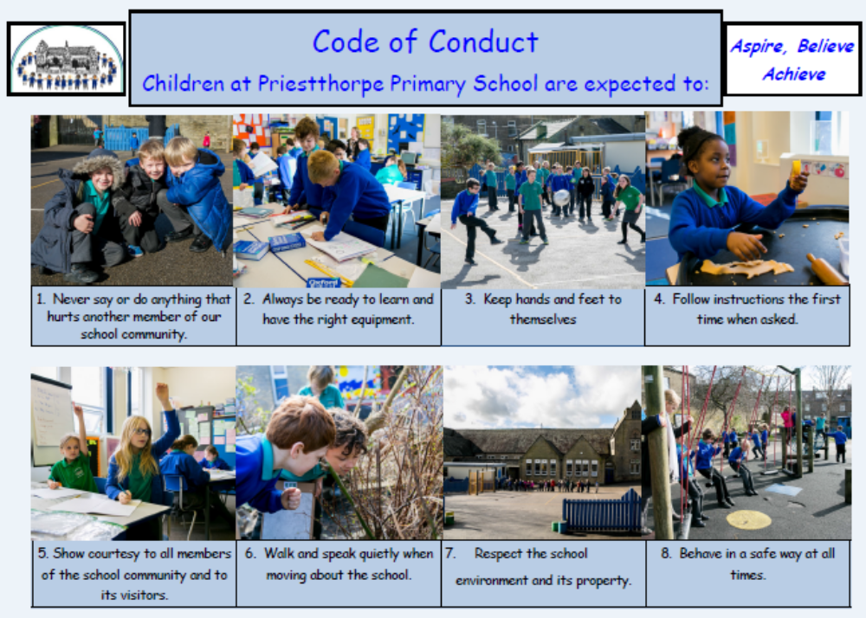

Priestthorpe Primary School- Aspire, Believe, Achieve
Our school rules help all of us to make our school a good place to be and a good place to learn.
If you choose to break our school rules:
1 – Your name will be written in the yellow book with the number of the rule you broke.
2 – If you continue to break the rules your name will be entered for a second time.
3 – If you still continue to break the rules you will have your name written in the red book.
An entry in the red book means you will have a learning conversation with Mrs Gunning, Mrs Nolan or Mrs Cartman and your parents will be contacted.
If you hurt anyone by using words or actions you will receive an immediate entry in the red book.

Background to our behaviour policy:
What we want to create within school is a positive atmosphere where the children understand the reasons for keeping the rules. We will talk to the children about making Priestthorpe Primary School a good place to be. The journey that each child will go on as they move through our school will be a different one and we want to ensure that everyone feels able to take a chance and engage fully with the work they are doing because they are enjoying it.
Stars of the week, good work and other individual rewards will still remain as will jewels in the chest for whole class rewards.
Exclusions

The school has a separate exclusions policy which must be referred to when needed.

Severe behaviour incidents

Severe behaviour incidents, such as racism and bullying, are instantly reported to and dealt with by the Headteacher, Deputy or Assistant Headteacher.

Written: C Gunning August 2014

