Priestthorpe Primary School
Pupil Premium Grant Expenditure
Report 2014/15
Context of the school
Priestthorpe Primary School is a one form entry school in the centre of Bingley. We have a 30 place nursery and are an active member of the 4LC family of schools.

We have very high aspirations for our children and we believe that no child should be left behind. We strongly believe that it is not about your background but your passion and thirst for knowledge, and dedication to learning that make the difference between success and not reaching full potential. We are determined to ensure that all our children are given every opportunity to realise their full potential.

The Pupil Premium Grant (PPG) funding is part of our budget and we are committed to spending it to full effect. We believe that one of the biggest barriers for children can be ‘poverty of expectation’ and so we are committed to creating a climate that does not limit a child’s potential in any way.
Objectives of Pupil Premium Grant
When making decisions about using the PPG funding it is important to consider the context of the school and the challenges faced. Common barriers for our disadvantaged children can be:
- Less support from home
- Weak language and communication skills
- Lack of confidence
- More frequent behaviour difficulties
- Attendance and punctuality issues
- Lack of aspiration and ambition
- Lack of parental support at home

There can also be complex family situations that prevent children from flourishing. The challenges and situations are varied and there is no one size fits all. Our key objective in using the PPG is to narrow the gap between pupil groups. As a school we aim for good progress for all children, but historically and indeed nationally the attainment of FSM children has been lower. Through quality first teaching and targeted interventions we are constantly working to eliminate barriers to learning and progress. For the children who start school with low attainment on entry, our aim is to ensure that they make accelerated progress in order to reach age related expectations and above as they move through school.

We continually analyse our data thoroughly, meet with teachers and look at each child as an individual in terms of progress and attainment. We have also thought carefully about the children and identified where additional activities and experiences would support the development of the whole child, not just as a learner.

Year | 2014-15
Number of FSM in school | 32 (October census)
Total number of children eligible for PPG | 42 (21%)
Amount of PPG received per pupil | £1323
Total amount of PPG received | £65,999

PPPG has enabled the school to support children in the following ways:
- Delivering interventions to help accelerate pupil progress
- Providing an additional teacher to help the children learn phonics in KS1
- Provide a homework club to support children with their learning
- Provide learning mentor support to develop attitudes to learning
- Provide a forest schools practitioner to develop the children’s concentration, enthusiasm and thirst for learning
- Enabling children to attend residential/trips
- Uniform assistance
- Software to support the progress of children with language development

Pupil Premium Expenditure 2014/15 Academic Year
Outdoor Learning |  |  |  | 5540
Uniform Assistance |  |  |  | 1839
Financial Support re: Trips (Inglebrough) (9 x £115) |  |  |  | 1035
Learning mentor costs inc homework club costs 1hr/week |  |  |  | 17,368
Pupil premium learning support assistant |  |  |  | 13042
TA Employment Costs - level 2 6TA’s (Y1-6) equivalent of 2 hrs a day TTO |  |  |  | 27.933
Nessy Licence |  |  |  | 350
Financial Support re: other school trips and resources |  |  |  | 154
 |  |  |  | 67,261

Impact of Pupil Premium Grant
Narrowing the Gap between PPG children and other Non-PPG children
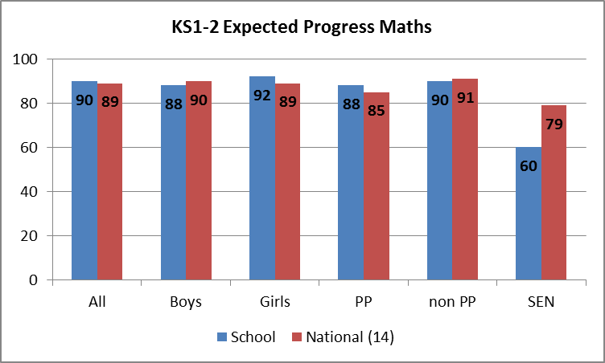
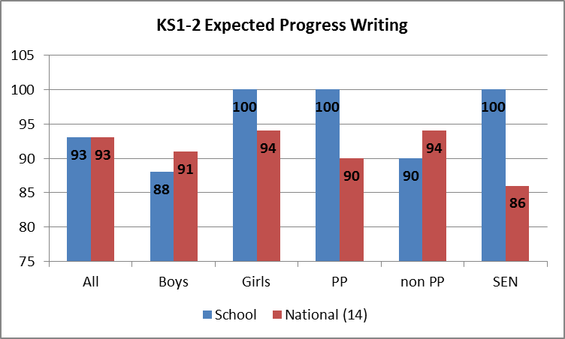
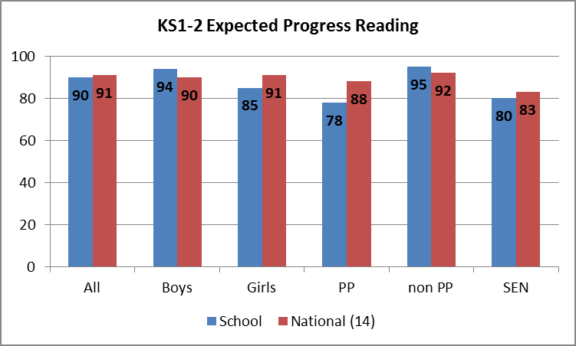

Implications for Pupil Premium spending 2015/16
Funding priorities moving forward:
- Children receive quality intervention from the class teacher/specially trained teaching assistants following the writing of personal intervention plans for each child
- Commando Joe one day a week to build self-esteem, raise aspirations and work on the resilience of our children
- Cookery club with the pastoral team once a week
- Targetted homework club 1 hour a week
- SATS and other booster groups by SLT
- Headteacher Pupil Premium Conference to explore good practice
- Learning mentor costs – ongoing
- Parental involvement worker (new post)
- Uniform assistance
- Continued financial support for trips etc..

We have identified some key principles which will maximise the impact of our PPG
Building belief –
- We have a culture where staff believe in ALL our children
- where there are no ‘excuses’ for underperformance
- staff adopt a ‘solution focussed approach to overcoming barriers and staff support children to become powerful learners
Improving day to day teaching –
- setting high expectations
- ensure consistent implication of non-negotiables
- share good practice and improve assessment through joint levelling and moderation within school and with other local schools.
Increasing learning time – maximise the time children have to learn and ‘catch up’ by
- improve attendance
- refining the timetable and providing earlier intervention for KS1 children to accelerate progress so that Y1 phonics check and KS1 results are better for FSM children
Individualising support –
- looking at the individual needs of each child
- ensure additional support and class teacher communicate effectively
- matching the skills of the intervention staff to the intervention they provide
- safeguarding five afternoons a week of designated, targeted support from specially trained support staff
- Provide more opportunities for a breadth of experience as well as academic progress
Pupil Premium Grant Due 2015/16
Number of FSM in school | 31 (October Census Day)
Total number of children eligible for PPG | 49 (26%)
Amount of PPG received per pupil | £1320
Total number of children eligible for service PPG | 1
Total number of children eligible for post-LAC PPG | 3
Total amount of PPG receivable | £70,680

