

Year Three

Parents’ Leaflet

How to support your child

with Maths at home

**By the end of Year 3 your child should;**

* Read and write numbers to at least 1000
* Recognise place value of all numbers in any 3-digit number
* Count in multiples of: 2, 3, 4, 5, 8, 10, 50 and 100 from 0
* Know 100 more or less than any number up to 1000
* Add together 3-digit numbers using column method.
* Subtract 2 3-digit numbers using column method.
* Recall and use multiplication and division facts for: 2, 3, 4, 5, 8 and 10
* Multiply any 10s number by a 2, 3, 4, 5, 8 or 10
* Know pairs of fractions that add up to 1
* Use £.p and know value of amounts
* Tell time to nearest 5 minutes

**Ideas for games you can play around the house**

Fractions

Use 12 buttons, or paper clips or dried beans or…

♦ Ask your child to find **half** of the 12 things.

♦ Now find one **quarter** of the same group.

♦ Find one **third** of the whole group.

Repeat with other numbers

[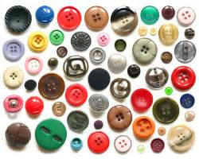](http://images.search.yahoo.com/images/view;_ylt=A2KJkPmvmU1SZ1EADOqJzbkF;_ylu=X3oDMTFybmFyODFqBHNlYwNzcgRzbGsDaW1nBG9pZANlNTFmMGQ0NmU4NmU2ZjRiNDU3MzBmYjgwZDk1NDdiMQRncG9zAzE1?back=http://images.search.yahoo.com/yhs/search?p%3Dbuttons%26hsimp%3Dyhs-yhsifmclone1%26hspart%3DBabylon%26tab%3Dorganic%26ri%3D15&w=250&h=200&imgurl=www.recyclethis.co.uk/wp-content/uploads/2009/04/buttons.jpg&rurl=http://www.recyclethis.co.uk/20090420/how-can-i-reuse-or-recycle-random-spare-buttons&size=57KB&name=...+can+I+reuse+or+recycle+random+spare+%3cb%3ebuttons%3c/b%3e?+|+How+can+I+recycle+this&p=buttons&oid=e51f0d46e86e6f4b45730fb80d9547b1&fr2=&fr=&tt=...+can+I+reuse+or+recycle+random+spare+%3cb%3ebuttons%3c/b%3e?+|+How+can+I+recycle+this&b=0&ni=160&no=15&ts=&tab=organic&sigr=12l5scj7u&sigb=13bath64q&sigi=11s98hp0t&.crumb=xmYZPvxvIA6&hsimp=yhs-yhsifmclone1&hspart=Babylon)

Order, order!

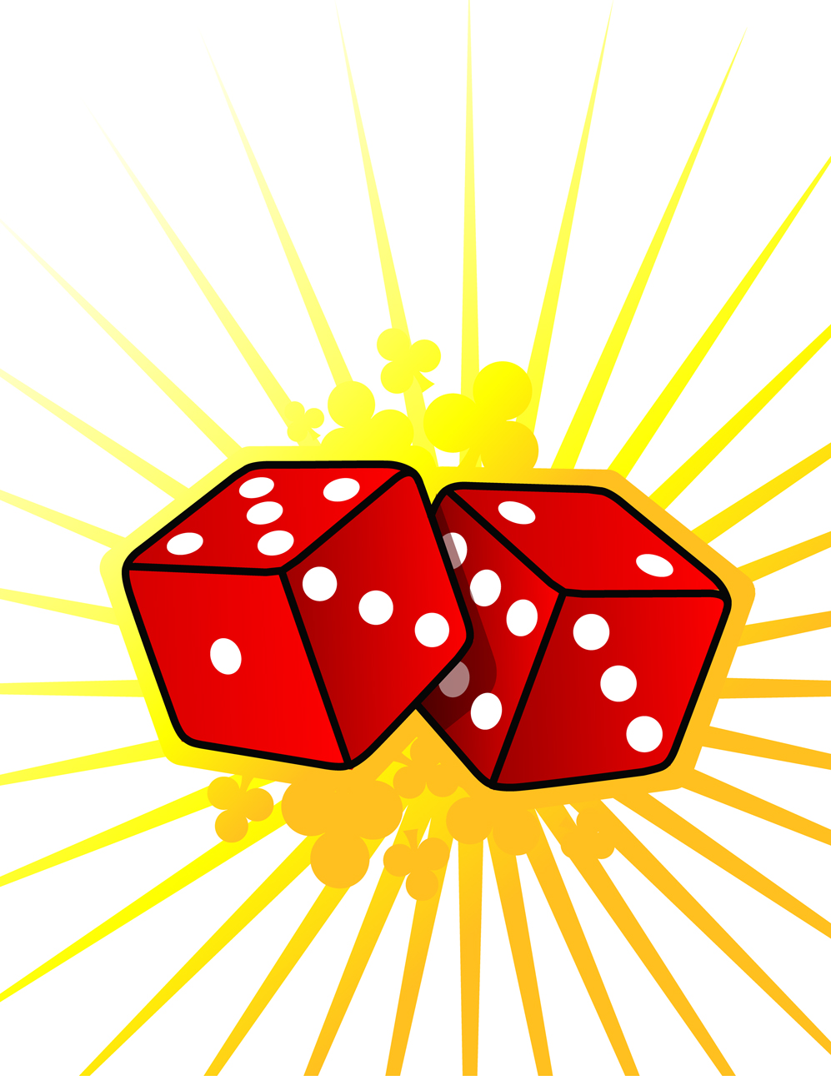

♦ Each of you should draw 6 circles in a row

♦ Take turns

♦ Roll two dice and make a two-digit number (see Number games)

♦ Write the number in one of your circles. Once the number is written in a circle you cannot change it or move it!

♦ The first to get all six of their circle numbers in order wins

***Number games***

Roll two dice. Make two-digit numbers, e.g. if you roll a 6 and 4,

this could be 64 or 46. If you haven’t got two dice, roll one dice

twice. Ask your child to do one or more of the activities below

♦ Count on or back from each number in tens

♦ Add 19 to each number in their head. (A quick way is to add 20 then take away 1.)

♦ Subtract 9 from each number. (A quick way is to take away 10 then add back one.)

♦ Double each number C:\Users\i.cork\AppData\Local\Microsoft\Windows\Temporary Internet Files\Content.IE5\NW0VCS6W\MC900116354[1].wmf

**Board games**

For these games you need to sketch a board like this. Notice how the numbers are arranged.

[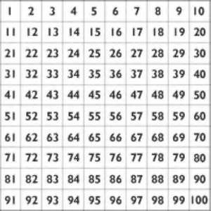](http://images.search.yahoo.com/images/view;_ylt=A2KJkIXCm01SO1gAT0WJzbkF;_ylu=X3oDMTFxMGh1aXU5BHNlYwNzcgRzbGsDaW1nBG9pZANmMzBkYWQ4N2MyOWU5ZjUxMDNjMTVhMTRiYjdjYmNiYwRncG9zAzM-?back=http://images.search.yahoo.com/yhs/search?p%3Dnumber%2Bsquare%26hsimp%3Dyhs-yhsifmclone1%26hspart%3DBabylon%26tab%3Dorganic%26ri%3D3&w=562&h=562&imgurl=www.test02.eddiesmith.net/wp-content/uploads/2012/08/number-square.jpg&rurl=http://www.stnicholas.bristol.sch.uk/our-learning/support-your-child/&size=176.4KB&name=%3cb%3enumber+square%3c/b%3e&p=number+square&oid=f30dad87c29e9f5103c15a14bb7cbcbc&fr2=&fr=&tt=%3cb%3enumber+square%3c/b%3e&b=0&ni=160&no=3&ts=&tab=organic&sigr=125ic4u10&sigb=13gk9k43l&sigi=126vuur5g&.crumb=xmYZPvxvIA6&hsimp=yhs-yhsifmclone1&hspart=Babylon)

♦ Start on 1. Toss a coin. If it lands heads, move 1 place along. If it lands tails, add 10, saying the total correctly before moving. First person to reach the bottom row wins.

♦ Start anywhere on the board. Roll a dice. Even numbers move you forwards and odd numbers move you backwards. If you land on a multiple of five, you can move either 10 forwards or 10 backwards. The first person to reach either the top or bottom of the board wins.

♦Guess with your child the weights of people in your home

**Up and down the scales**

♦ Then weigh them (if they agree!). Help your child to read the scales

♦ Record each weight, then write all the weights in order

Repeat after two weeks. What, if any, is the difference in the weight?

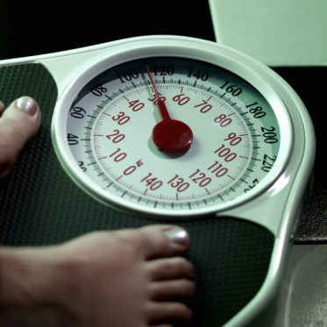

**Bean race**

You need two dice and a pile of dried beans

♦ Take turns to roll the two dice

♦ Multiply the two numbers and call out the answer

♦ If you are right, you win a bean

♦ The first to get 10 beans wins C:\Users\i.cork\AppData\Local\Microsoft\Windows\Temporary Internet Files\Content.IE5\UO9RTETL\MC900215377[1].wmf

**Make 20**

For this game you need to write out numbers 0 to 20 on a piece of paper. Make them big enough to put counters or coins on.

♦ Take turns. Roll a dice. Put a coin on the number that goes with the dice number to make 20, e.g. throw a ‘4’ and put a coin on 16

♦ If someone else's counter is there already, replace it with yours!

♦ The first person to have counters on 6 different numbers wins

♦ Now roll two dice, add the numbers together and look for a number to make 20. The first with coins on 10 different numbers wins

**Guess my number**

Choose a car number you can see, e.g. 592.

♦ Add 10 to the number in your head. Say the answer aloud

♦ Can your child guess which car you were looking at? If so she or he can have a turn next

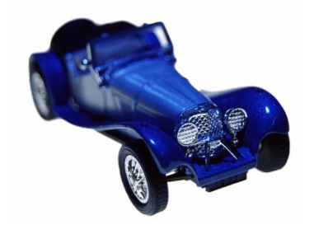

**Secret number sentences**

♦ Ask your child to say a number, e.g. 43

♦ Secretly do something to it (e.g. add 30). Say the answer, e.g. 73.

♦ The child then says another number to you, e.g. 61

♦ Do the same to that number and say the answer

♦ The child has to guess what you are doing to the number each time!

♦ Then they can have a turn at secretly adding or subtracting something to each number that you say to them

**Cupboard maths**

Ask your child to look at the weights printed on jars, tins and packets in the food cupboard, e.g. tinned tuna 185g

tinned tomatoes 400g

jam 454g

C:\Users\i.cork\AppData\Local\Microsoft\Windows\Temporary Internet Files\Content.IE5\0SAMUKE9\MC900001752[1].wmf C:\Users\i.cork\AppData\Local\Microsoft\Windows\Temporary Internet Files\Content.IE5\Q8V7GKM0\MC900325406[1].wmf C:\Users\i.cork\AppData\Local\Microsoft\Windows\Temporary Internet Files\Content.IE5\A070IYVQ\MC900333948[1].wmf C:\Users\i.cork\AppData\Local\Microsoft\Windows\Temporary Internet Files\Content.IE5\GPDO1NH5\MC900300073[1].wmf

Choose six items. Ask your child to put them in order. Is the largest item the heaviest?

**Bingo!**

One person has the 2x table and the other has the 5x table. Write six numbers in that table on your piece of paper, e.g.

4 8 10 16 18 20

♦ Roll one or two dice. If you choose to roll two dice, add the numbers, e.g. roll two dice, get 3 and 4, add these to make 7.

♦ Multiply that number by 2 or by 5 (that is, by your table number, e.g. 7 x 2 or 7 x 5).

♦ If the answer is on your paper, cross it out.

♦ The first to cross out all six of their numbers wins.

[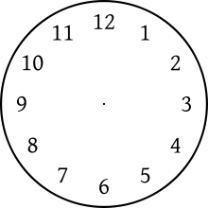](http://www.google.co.uk/url?sa=i&source=images&cd=&cad=rja&docid=EuPI-ildoRxTWM&tbnid=gnl_kpriSAkuAM:&ved=0CAgQjRwwAA&url=http://en.wikipedia.org/wiki/Clock_position&ei=NopMUrO5N-eG0AWK4IDQDQ&psig=AFQjCNEgKmKBES0-9t3R2iOoywCjOS2Y7Q&ust=1380834231035619)

**What time is it please?**

**Can you tell the time?**

Whenever possible, ask your child to tell you the time to the nearest 5 minutes. Use a clock with hands as well as a digital watch or clock.

Also ask:

♦ What time will it be one hour from now?

♦ What time was it one hour ago?

Time your child doing various tasks, e.g.

♦ getting ready for school;

♦ tidying a bedroom;

♦ saying the 5 times, 10 times or 2 times table…

Ask your child to guess in advance how long they think an activity will take. Can they beat their time when they repeat it?



Internet resources

Hit the Button

www.woodlands-junior.kent.sch.uk/maths

mathschamps.co.uk (Brick blaster)

www.topmarks.co.uk

www.mathszone.co.uk

www.bbc.co.uk/bitesize/ks2/maths

www.primaryinteractive.co.uk

Maths Magician (coolsciencelab.com/math_magician)

MyMiniMaths – This is a fantastic resource which gives children the opportunity to practise all aspects of the curriculum for their year group. Every day 8 questions are given and the answers are available.

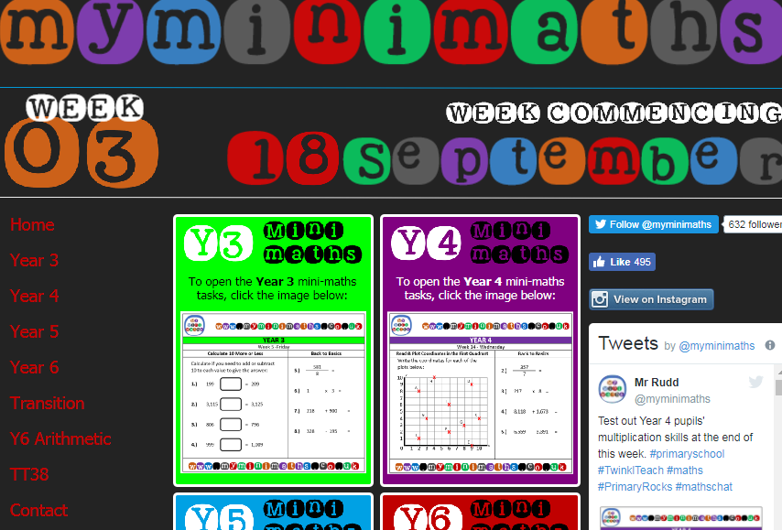

The Government has introduced a new National Curriculum for Maths in September 2014. Enclosed is the programme of study for this year group which states what children should be taught and know by the end of the year.

**Year 3 programme of study**

**By the end of the year children should be able to:**

**Number - number and place value**

* count from 0 in multiples of 4, 8, 50 and 100; find 10 or 100 more or less than a given number
* recognise the place value of each digit in a 3-digit number (100s, 10s, 1s)
* compare and order numbers up to 1,000
* identify, represent and estimate numbers using different representations
* read and write numbers up to 1,000 in numerals and in words
* solve number problems and practical problems involving these ideas

**Number - calculations**

* add and subtract numbers mentally, including:
  + a three-digit number and 1s
  + a three-digit number and 10s
  + a three-digit number and 100s
* add and subtract numbers with up to 3 digits, using formal written methods of columnar addition and subtraction
* estimate the answer to a calculation and use inverse operations to check answers
* solve problems, including missing number problems, using number facts, place value, and more complex addition and subtraction
* recall and use multiplication and division facts for the 3, 4 and 8 multiplication tables
* write and calculate mathematical statements for multiplication and division using the multiplication tables that they know, including for two-digit numbers times one-digit numbers, using mental and progressing to formal written methods
* solve problems, including missing number problems, involving multiplication and division, including positive integer scaling problems and correspondence problems in which n objects are connected to m objects

**Number - fractions**

* count up and down in tenths; recognise that tenths arise from dividing an object into 10 equal parts and in dividing one-digit numbers or quantities by 10
* recognise, find and write fractions of a discrete set of objects: unit fractions and non-unit fractions with small denominators
* recognise and use fractions as numbers: unit fractions and non-unit fractions with small denominators
* recognise and show, using diagrams, equivalent fractions with small denominators
* add and subtract fractions with the same denominator within one whole [for example, 5/7+ 1/7= 6/7]
* compare and order unit fractions, and fractions with the same denominators
* solve problems that involve all of the above

**Measurement**

* measure, compare, add and subtract: lengths (m/cm/mm); mass (kg/g); volume/capacity (l/ml)
* measure the perimeter of simple 2-D shapes
* add and subtract amounts of money to give change, using both £ and p in practical contexts
* tell and write the time from an analogue clock, including using Roman numerals from I to XII, and 12-hour and 24-hour clocks
* estimate and read time with increasing accuracy to the nearest minute; record and compare time in terms of seconds, minutes and hours; use vocabulary such as o’clock, am/pm, morning, afternoon, noon and midnight
* know the number of seconds in a minute and the number of days in each month, year and leap year
* compare durations of events [for example, to calculate the time taken by particular events or tasks]

**Geometry - properties of shapes**

* draw 2-D shapes and make 3-D shapes using modelling materials; recognise 3-D shapes in different orientations and describe them
* recognise angles as a property of shape or a description of a turn
* identify right angles, recognise that 2 right angles make a half-turn, 3 make three-quarters of a turn and 4 a complete turn; identify whether angles are greater than or less than a right angle
* identify horizontal and vertical lines and pairs of perpendicular and parallel lines

**Statistics**

* interpret and present data using bar charts, pictograms and tables
* solve one-step and two-step questions [for example ‘How many more?’ and ‘How many fewer?’] using information presented in scaled bar charts and pictograms and tables